Ogiery stacjonujące w Stadninie Koni Kozienice w 2013r.

- FAST AND FURIOUS sk. gniady ur. 2001r. (Fr)

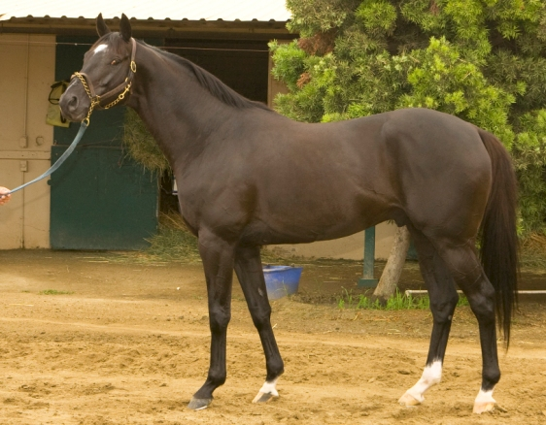

SINGSPIEL (IRE)  b. 1992 | IN THE WINGS (GB)  b. 1986 [CS] | SADLERS WELLS (USA)  b. 1981 [CS] | NORTHERN DANCER (CAN) | b. 1961 [BC]
SINGSPIEL (IRE)  b. 1992 | IN THE WINGS (GB)  b. 1986 [CS] | SADLERS WELLS (USA)  b. 1981 [CS] | FAIRY BRIDGE (USA) | b. 1975 *
SINGSPIEL (IRE)  b. 1992 | IN THE WINGS (GB)  b. 1986 [CS] | HIGH HAWK (IRE)  b. 1980 | SHIRLEY HEIGHTS (GB) | br. 1975 [CP]
SINGSPIEL (IRE)  b. 1992 | IN THE WINGS (GB)  b. 1986 [CS] | HIGH HAWK (IRE)  b. 1980 | SUNBITTERN (GB) | gr. 1970
SINGSPIEL (IRE)  b. 1992 | GLORIOUS SONG (CAN)  b. 1976 | HALO (USA)  blk. 1969 [BC] | HAIL TO REASON (USA) | dkb/br. 1958 [C]
SINGSPIEL (IRE)  b. 1992 | GLORIOUS SONG (CAN)  b. 1976 | HALO (USA)  blk. 1969 [BC] | COSMAH (USA) | b. 1953 *
SINGSPIEL (IRE)  b. 1992 | GLORIOUS SONG (CAN)  b. 1976 | BALLADE (USA)*  b. 1972 | HERBAGER (FR) | b. 1956 [CS]
SINGSPIEL (IRE)  b. 1992 | GLORIOUS SONG (CAN)  b. 1976 | BALLADE (USA)*  b. 1972 | MISS SWAPSCO (USA) | dkb/br. 1965
HELVELLYN (USA)  b. 1990 | GONE WEST (USA)  b. 1984 | MR. PROSPECTOR (USA)  b. 1970 [BC] | RAISE A NATIVE (USA) | ch. 1961 [B]
HELVELLYN (USA)  b. 1990 | GONE WEST (USA)  b. 1984 | MR. PROSPECTOR (USA)  b. 1970 [BC] | GOLD DIGGER (USA) | b. 1962 *
HELVELLYN (USA)  b. 1990 | GONE WEST (USA)  b. 1984 | SECRETTAME (USA)  ch. 1978 | SECRETARIAT (USA) | ch. 1970 [IC]
HELVELLYN (USA)  b. 1990 | GONE WEST (USA)  b. 1984 | SECRETTAME (USA)  ch. 1978 | TAMERETT (USA) | br. 1962 *
HELVELLYN (USA)  b. 1990 | ACCREDITED (USA)  b. 1981 | ALLEGED (USA)  b. 1974 | HOIST THE FLAG (USA) | b. 1968 [BI]
HELVELLYN (USA)  b. 1990 | ACCREDITED (USA)  b. 1981 | ALLEGED (USA)  b. 1974 | PRINCESS POUT (USA) | b. 1966
HELVELLYN (USA)  b. 1990 | ACCREDITED (USA)  b. 1981 | BELLE DE NUIT (USA)  gr. 1963 | WARFARE (USA) | gr. 1957
HELVELLYN (USA)  b. 1990 | ACCREDITED (USA)  b. 1981 | BELLE DE NUIT (USA)  gr. 1963 | EVENING BELLE (USA) | b. 1945

Kariera wyścigowa:
Francja - 2-letni 2 starty, 2xI (PRIX DE SAINT DESIA),
- 3 letni 2xI (DERBY du LANGUEDOC), 1xIII (PRIX NOILES [G2])
USA - 3 letni i starszy: 1xI, 1xII (HOLLYWOOD DERBY [G1]
2xIII (SHOEMAKER BREEDEKS CUP MILES [G1]),
(AMERICAN INVITATIONAL H.[G2]).
Suma wygranych 372 922 $ (USA)
Cena stanówki – 1.500,00 PLN

- SCUFIOTT kasztan, ur. 2002r. (GB)

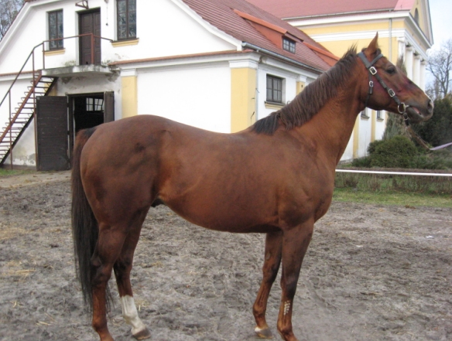

GIANTS CAUSEWAY (USA)  ch. 1997 [C] | STORM CAT (USA)  br. 1983 | STORM BIRD (CAN)  b. 1978 | NORTHERN DANCER (CAN) |  | b. 1961 [BC]
GIANTS CAUSEWAY (USA)  ch. 1997 [C] | STORM CAT (USA)  br. 1983 | STORM BIRD (CAN)  b. 1978 | SOUTH OCEAN (CAN) |  | b. 1967 *
GIANTS CAUSEWAY (USA)  ch. 1997 [C] | STORM CAT (USA)  br. 1983 | TERLINGUA (USA)  ch. 1976 | SECRETARIAT (USA) |  | ch. 1970 [IC]
GIANTS CAUSEWAY (USA)  ch. 1997 [C] | STORM CAT (USA)  br. 1983 | TERLINGUA (USA)  ch. 1976 | CRIMSON SAINT (USA) |  | ch. 1969 *
GIANTS CAUSEWAY (USA)  ch. 1997 [C] | MARIAH'S STORM (USA)  b. 1991 | RAHY (USA)  ch. 1985 | BLUSHING GROOM (FR) |  | ch. 1974 [BC]
GIANTS CAUSEWAY (USA)  ch. 1997 [C] | MARIAH'S STORM (USA)  b. 1991 | RAHY (USA)  ch. 1985 | GLORIOUS SONG (CAN) |  | b. 1976
GIANTS CAUSEWAY (USA)  ch. 1997 [C] | MARIAH'S STORM (USA)  b. 1991 | IMMENSE (USA)  b. 1979 | ROBERTO (USA) |  | b. 1969 [C]
GIANTS CAUSEWAY (USA)  ch. 1997 [C] | MARIAH'S STORM (USA)  b. 1991 | IMMENSE (USA)  b. 1979 | IMSODEAR (USA) |  | b. 1967 *
BE MINE (IRE)  b. 1995 | WOLFHOUND (USA)  ch. 1989 | NUREYEV (USA)  b. 1977 [C] | NORTHERN DANCER (CAN) |  | b. 1961 [BC]
BE MINE (IRE)  b. 1995 | WOLFHOUND (USA)  ch. 1989 | NUREYEV (USA)  b. 1977 [C] | SPECIAL (USA) |  | b. 1969 *
BE MINE (IRE)  b. 1995 | WOLFHOUND (USA)  ch. 1989 | LASSIE DEAR (USA)*  b. 1974 | BUCKPASSER (USA) |  | b. 1963 [C]
BE MINE (IRE)  b. 1995 | WOLFHOUND (USA)  ch. 1989 | LASSIE DEAR (USA)*  b. 1974 | GAY MISSILE (USA) |  | b. 1967
BE MINE (IRE)  b. 1995 | UPPER STRATA (IRE)  b. 1985 | SHIRLEY HEIGHTS (GB)  br. 1975 [CP] | MILL REEF (USA) |  | b. 1968 [CS]
BE MINE (IRE)  b. 1995 | UPPER STRATA (IRE)  b. 1985 | SHIRLEY HEIGHTS (GB)  br. 1975 [CP] | HARDIEMMA (GB) |  | b. 1969
BE MINE (IRE)  b. 1995 | UPPER STRATA (IRE)  b. 1985 | BRIGHT LANDING (GB)  ch. 1978 | SUN PRINCE (GB) |  | ch. 1969
BE MINE (IRE)  b. 1995 | UPPER STRATA (IRE)  b. 1985 | BRIGHT LANDING (GB)  ch. 1978 | LAND HO (GB) |  | b. 1969

Pierwszy przychówek:
Ogier LASCADELL - 3 letni – dwa zwycięstwa w płotach (BOJGARDA, ZAMKNIĘCIA SEZONU PŁOTOWEGO)
Cena stanówki – 1.000,00 PLN

Kontakt: 48 614 23 33

